CHAPTER 4: Chemical patterns

Worksheet 4.3

Electron shells
Answers

Electron configuration
1. Complete the following table.
Atom or ion | Proton number | Electron number | Electron configuration
Sodium atom (Na) | 11 | 11 | 2, 8, 1
Fluorine atom (F) | 9 | 9 | 2, 7
Carbon atom (C) | 6 | 6 | 2, 4
Calcium atom (Ca) | 20 | 20 | 2, 8, 8, 2
Chloride ion (Cl–) | 17 | 18 | 2, 8, 8
Oxide ion (O^{2–}) | 8 | 10 | 2, 8
Magnesium ion (Mg²⁺) | 12 | 10 | 2, 8
Aluminium ion (Al³⁺) | 13 | 10 | 2, 8

Exciting the electrons
2. A student performed the experiment shown in the diagram below.
 | 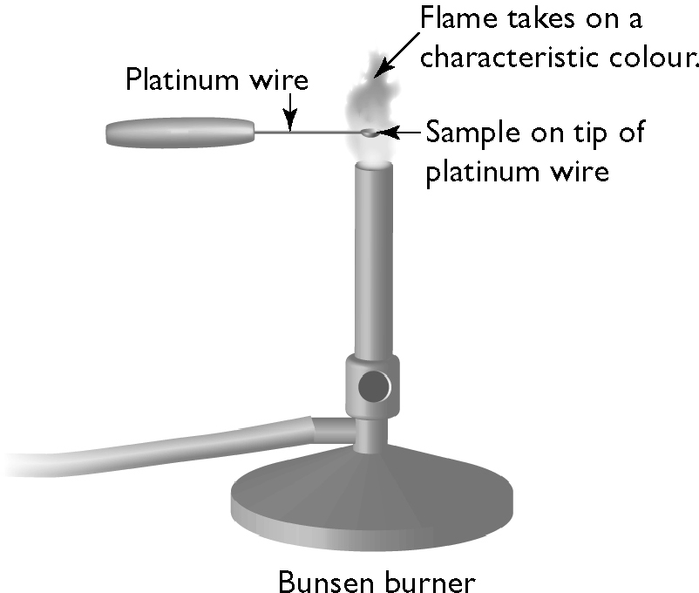 |  | A sample of salt (sodium chloride) is placed on the tip of a platinum wire. When the sample is heated in a blue Bunsen flame the flame turns yellow.  Use the theory of electron shells to explain this observation.  The electrons in the sodium ion absorb energy from the flame and move to higher unstable or excited shells. They then fall back to lower energy shells and the energy is released as light of various wavelengths. The yellow colour of the flame is the result of the emission of yellow light from the hot ions.

Electron shell population
3. Each electron shell is represented by a number (n) as shown in the following table.
Shell number (n) Maximum electron population  1 2(1²) = 2  2 2(2²) = 8  3 2(3²) = 18  4 2(4²) = 32 |  | The maximum electron number in each shell is given by the formula:  maximum electron number = 2n²  Complete the table by calculating the maximum electron population in each shell.

